FACULTY PROFILE
Mrs. J.N. Erande
Assistant Professor
Department of Electrical Engineering

Row house no.3, Jagtap mala, near Taran Talav ,Nashik road ,Nashik  Nashik - 422101  Mob: 7498698845  Email ID: jayashri.erande@ges-coengg.org | 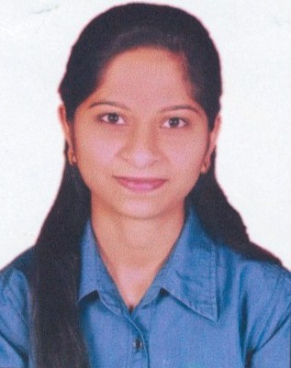
QUALIFICATION
- ME (Electrical Power Systems)
- BE (Electrical Engineering)
TEACHING EXPERIENCE
- Current experience: 9 months
- Past experience: 4.5 year
RESEARCH PUBLICATIONS
- “Enhancing Microgrid Stability through a Hybrid Virtual Synchronous Machine Topology”, IJRASET International journal paper published in June 2023.
- ‘Protection of three phase induction motor and detection of fault’, in the traction machine workshop in April 2019.
ADMINISTRATIVE WORK
Sr. No. | Post | Description
1. | Admission process | Doing work in the Admission process in the CAP ,form filling in the software.

FDP/WORKSHOP/WEBINAR/SEMINAR ATTENDED
1. Securing 3rd position in Master in Power System at the college level.
2. Certification course of Electrical AutoCAD.
3. Three days training on” Industrial energy management and audit”.
4. Certification program of three days on “program for smart grid”.
5. Doing technical and non-technical certification courses on Coursera.

Mrs. J.N.Erande

