FACULTY PROFILE
Mrs. M. P Deshpande
Assistant Professor
Department of Electerical Engineering

Pravar Banglow, Gangotri Vihar Colony,  Amrutdham, Panchavati,  Nashik - 422003  Mob: 8855845494  Email ID: monika.deshpande@ges-coengg.org | 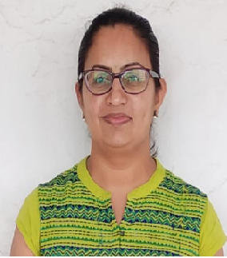
QUALIFICATION
- ME (Electrical Power Systems)
- BE (Electrical Engineering)
TEACHING EXPERIENCE
- Current experience: 12.5 years
- Past experience: 6 months
RESEARCH PUBLICATIONS
- “Unified Power Quality Conditioner for Three Phase Four Wire Distribution System”, IEEE International Conference on Innovations in Information, Embedded and Communication Systems in March 2015, at Karpagam College of Engineering, Coimbatore, Tamilnadu.
- “Unified Power Quality Conditioner for Three Phase Distributon system”, in IEEE International Conference on Smart Grid Systems, at Lisbon Portugal in July 2015.
- “Power Quality Conditioner for Microgrid”, in National Conference on Advances in Renewable & Sustainable Energy (ARSE-2015), at JNCT, Bhopal.
- “Power Quality Improvement in Microgrid by Using Unified Power Quality Compensator”, in ICETST SSSTUMS, Sehore, M.P.
ADMINISTRATIVE WORK
Sr. No. | Post | Description
1. | Department exam Coordinator | To share all information related to university exam received from college exam office with all department faculty and students. To schedule unit test at department levelfor all classes
2. | TE Class Coordinator | To make midsem and endsem attendance record of TE B class. To communicate with parents regarding less attendance of students if any. To keep the record of students having any medical problem as well as record of students achievements. To keep the academic performance record i.e. slow and advanced student record.
2. | ‘Resonance-annual magazine’ Coordinator | To collect the department data and articles from magazine committee members of each department and students, compilation and proof checking by coordinating with printing press
UNIVERSITY RESPONSIBILTITES
Sr. No. | Post | Duties
1. | Subject Expert | Subject Expert for the Local Management  University of Pune
2. | Additional Subject chairman, | Material Science
3. | Examiners (External and Internal) | Practical and Theory subjects of Engineering
4. | Junieor Supervisor (Internal) | Theory

FDP/WORKSHOP/WEBINAR/SEMINAR ATTENDED
- Completed successfully 12 week NPTEL Course of Electrical Machines II, organized by IIT Kharagpur, jan-apr2023.
- Attended FDP on Ansys Maxwell: Tools and Research organized by GES RHSCOEMS and R, Nashik, 11/04/2023 to 13/04/2023

Mrs. M.P. Deshpande

