FACULTY PROFILE

**Mr Harshavardhan Vijay Kulkarni Assistant Professor**

House No 8,Varad Bunglow, Ravishankar Marg, Nashik Mob: 9916134281

Email ID: [kulkarni.harshavardhan@ges-coengg.org](mailto:kulkarni.harshavardhan@ges-coengg.org)

**QUALIFICATION**

* ME
* BE

**TEACHING EXPERIENCE**

* 1.5 Years in GESRHSCOEMSR, NASIK
* 14 Years Teaching

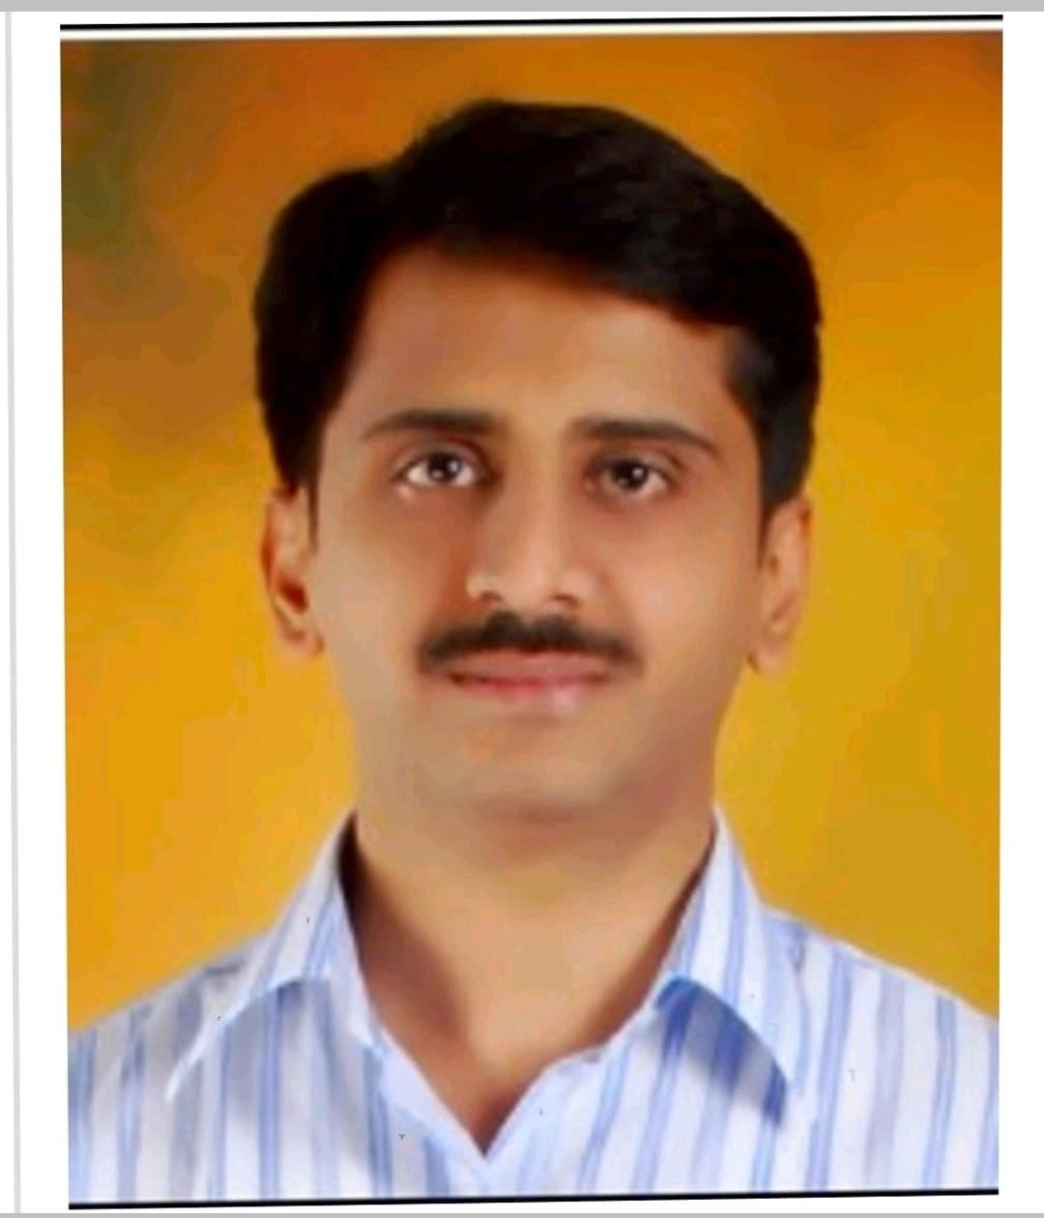

**INDUSTRY EXPERIENCE** *(One may delete this, if they don’t have an industry experience)*

* Commissioning Engineer at Taurus Powertronics Systems , Bangalore from 2005-2007

**RESEARCH PUBLICATIONS**

1. Automated Energy Monitoring And Controlling System

Authors: Keita Mohamed Mousthapa Harshavardhan V Kulkarni,

Publication date: 2018/7

Journal : Journal of Applied Science and Computations Volume 5, Issue 7, Pages 21-33

2. Modelling And Simulation Of Voltage Source Based On Space Vector Modulation Technique For Grid

Connection

Authors Harshavardhan V Kulkarni

Publication Date 2014/4

Journal : International Journal Of Multidisciplinary Research And Advances In Engineering Volume 6, Issue 2 , Pages 201-212 ,

Publisher NMIT Nitte Mangalore

**ADMINISTRATIVE WORK**

|  |  |  |
| --- | --- | --- |
| **Sr.**  **No.** | **Post** | **Description** |
| 1. | NAAC Committee -Member - Institute Level | To help Institute for NAAC data gathering ,uploading for DVV |
| 2. | NAAC-Criteria-II -Member at Department Level | To help Institute and Department for NAAC data gathering ,uploading for DVV |

**UNIVERSITY RESPONSIBILTITES**

|  |  |  |
| --- | --- | --- |
| **Sr.**  **No.** | **Post** | **Duties** |
| **1.** | Member | NIL |
| **2.** | Subject Expert | NIL |
| **3.** | Member | NIL |
| **4.** | Subject Chairman, | NIL |
| **5.** | Examiners  (External and Internal) | Junior Supervisor for End Sem SPPU exams  Junior Supervisor for In sem SPPU exams  External Examiner for Oral in SPPU OR/PR Exams |
| **6.** | Senior Supervisor (External and Internal) | NIL |

**Patents Granted/Published**

1**.** Title :  Artificial Intelligence-Driven Control System For High Voltage Gain Bldc

Motors With Optimized Duty Cycle In Electric Vehicles

Date/Year Sanctioned: 22/11/2024

Patent Office Journal No. 47/2024

Page No: 649

2. Title : Artificial Intelligence Based Axis High Safety Industrial Welding Robot

Date /Year Sanctioned :  22/03/2024

**FDP/WORKSHOP/WEBINAR/SEMINAR ATTENDED**

1. Participated in state level trouble shooting competition held at SDMCET, Dharwad
2. Attended one-week national seminar on SCADA Applications for Utilities held at NIT, Calicut.
3. Attended one week workshop on MATLAB for Engineers held at BEC, Bagalkot Pursued Industrial Training on Excitation Systems for two Months at BHEL-EDN
4. Bangalore.
5. Attended one day colloquium on Advanced topics in power systems engineering held at
6. BEC, Bagalkot.
7. Attended Two day FDP on Research Methodologies at KSIT , Bangalore
8. Attended TWO WEEKS ISTE hosted workshop on Signals & Systems from 2nd JAN 2014 to 12th JAN 2014
9. Attended TWO WEEKS ISTE hosted workshop on Control Systems from 2 nd DEC 2014 to 12th DEC 2014.
10. Attended 2 Day FDP on “Design and Implementation of Student Centered Learning” in association with Indo US Collaborative for Engineering Education, Footsteps and IIDEA during 5th and 6th January 2016.
11. Attended One day workshop about OBE (Outcome Based Education) by Dr. P.S Sastry a

pioneer in the outcome-based education on 12/03/2016.

1. Attended One day workshop on "Bhuvan Panchayat for Asset mapping & planning" held on December 04, 2015 at ISRO headquarters, Bangalore.
2. Attended One week FDP on IoRT(Internet of Robotic Things) at MSIRT Bangalore.
3. Attended “Issues and challenges in solar and wind power generation and utilization” from 4 th -7 th January 2017 at SIT, Tumkur.• Attended 3 days workshop on Linear

Integrated circuits at Acharya Institute Of Technology Bangalore from 6th Feb – 9 th Feb

2017.

1. Five days online FDP on ‘Advances in Renewable Energy and Smart Grid Integration

(31st May 2021-04th Jun 2021)’ organized by the Department of Electrical and

Electronics Engineering (EEE), ASET, Amity University, Uttar Pradesh, Noida

(UP),INDIA.

1. Five-day workshop on “Android Application Development" from 17/12/2020 to 21/12/2020 BY VIT JAIPUR from 17-21 DEC 2020.
2. Attended one-week AICTE Sponsored Online Short-Term Training Program (STTP) on

Green Internet of Things Phase III for Academicians and Researchers from 7th

December,2020 to 12th December, 2020 (in association with VESIT IQAC and

Institutes Innovation Council)

1. TEQIP-III Sponsored Five Day Faculty Development Program on “Issues & Challenges

in Grid Integration with Renewable Energy Sources” Organized By Rajasthan

Technical University, Kota Vivekananda Institute of Technology, Jaipur from

21/09/2020 to 25/09/2020

1. 6 days Virtual National Level FDP on ""National Education Policy: 2020 & Higher

Education in India” organized by Dr. N.S.A.M. First Grade College, Bengaluru -

89."For 6 Days From 24th-29th May 2021

**ACHIEVEMENTS**

**Papers Published**

1. AUTOMATED ENERGY MONITORING AND CONTROLLING SYSTEM, Keita

Mohamed Mousthapa Harshavardhan V Kulkarni, Publication date : 2018/7,Journal Journal of Applied Science and Computations Volume 5, Issue 7,Pages 21-33 ,Journal of Applied Science and Computations.

2Modelling And Simulation Of Voltage Source Based On Space Vector Modulation Technique For Grid Connection Authors Harshavardhan V Kulkarni Publication Date 2014/4 Journal : International Journal Of Multidisciplinary Research And Advances In Engineering Volume 6, Issue 2 , Pages 201-212 ,Publisher Nmit Nitte Mangalore

**NPTEL Online Courses Completed**

1. Completed with Elite Class in Online NPTEL online course on “Technical English for Engineers".
2. Completed with participation certificate on NPTEL online course on " Matlab for Numerical Computation".
3. Completed “Introduction to R language " an online course given by DATACAMP with a completion certificate.
4. Successfully completed NPTEL course on Smart Grid in 2019
5. Successfully completed NPTEL course on Teaching and Learning in Engineering in 2019
6. Teaching and Learning in Engineering.
7. Successfully completed NPTEL course on Electric Vehicles in 2019.

# Infosys Springboard Courses Completed

1. Successfully completed the course on “Introduction to Blockchain Technologies” Monday, November 7th 2022 Issued on: Saturday, February 18th 2023.
2. Successfully completed the course on “Python Fundamentals” on Saturday, January 7th 2023 Issued on: Tuesday, January 31st 2023
3. Successfully completed the course on “Problem Solving Using Computational Thinking” on October 22nd 2023.

# International talk

1. Topic: Solar photovoltaic system pollution performance by Mr. Harshavardhan Vijay Kulkarni Time: Jul 16, 2020 10:00 AM Pacific Time (US and Canada) for IEOM student chapter in collaboration with Concordia University, Canada.

# Internships conducted for Students

1. “Four Weeks Hands-on Internship on Python Numpy” In Association with IIC-AIT and Department of Electrical &Electronics Engineering At Acharya Institute of Technology, Department of Electrical and Electronics Engineering From Date: 02nd March 2021 To 27th March 2021.
2. Four weeks hands-on Internship of “SCILAB and Its Applications” organized by Department of EEE, Acharya Institute of Technology, Bengaluru, in association with AIT- IEEE student branch, from 11/10/2022 to 31/10/2022.

# Industrial Visits Conducted

Four days Industrial visit was conducted for 7th semester students to Varahi Underground Hydro power plant.

# Invited Talks arranged

1. Resource Person: Er.Ajay Kumar G, Manager (Das And Smart Grid) Bescom, Bengaluru Topic: Distribution Automation System And Smart Grid On 25.05.2020.
2. Resource Person: Mrs. Chandana Sasidharan, Senior Research Associate, AEEE, Delhi Topic: Electric Vehicle Charging Standards And New Electric Vehicles In India. On Date: 22.05.2020
3. Resource Person: Dr. Megha Singh, Data Analytics Science, Specialist, General Electric, Chennai Topic: Fault Diagnosis Of Three Phase Induction Motor Using Machine Learning On 24.05.2020
4. Resource Person: Mr. J. Srinivasan, M/S Ace Enablers Llp, Chennai

Topic: Power Quality And Energy Efficiency In Industry Perspective On 16.05.2020 And 17.05.2020

1. Resource Person: Er. Naganandini Ravichandran, Designation : Independent Researcher, Topic: “Floating Solar Pv System” on 31/05/2021.
2. Resource Person: Mr.Krishna Bharadwaj ,Director And Reseracher , Epsilon Scentific,Bangalore, Karnataka, India, Topic: Webinar On Residential Solar Pv Installations, Commissioning Of The System, Operations And Maintenance on 23-09-2021.
3. Resource Person: Dr. M U Kharat, Professor and Head, Computer Engineering Department, Met’s Institute of Engineering , Bhujbal Knowledge City Nashik, Maharashtra Webinar on “National Education Policy(NEP)-Innovation, Entrepreneurship & startup ” on 20th NOVEMBER 2021

Mr. Harshavardhan Vijay Kulkarni